Lesson Plan Implementation and Reflection:
Jing for Finance!

By: Joy Hopkins
Course: CEP 800 - Learning in School and Other Settings
Date: April 21, 2013

TABLE OF CONTENTS
About 3
Implementation 3
Reflection 5

About
The purpose of this document is to describe and reflect on a lesson plan geared to teach a group of eight finance professionals how to use Jing, a screenshot and screencast software. The main goal of the lesson was to teach the finance team at a Fortune 100 company how to use the software to create more robust desktop manuals and training materials to document their work processes. The underlying assumptions were that this would save time and money for the team and the company at large.
In my initial lesson plan, I was planning to create my own Jing presentation to teach the analysts the material. I ended up tweaking this strategy and simply using presentations that Jing had readily available on their website. The reason I went this route is that this software has had frequent updates in the last few years and I wanted the analysts to be comfortable going directly to the source for the latest version of the software and not having to rely on my presentation that may soon be out of date. I also found the existing training material to be very straight-forward and thorough, so was not sure I would add much value. Instead, I focused my time on leading hands-on learning sessions and guiding productive discussions on how this software could be best utilized to save the finance team time and money. I am happy to report it was time well spent.

Implementation
At the onset, I had gauged that the lesson’s success would be measured by the ability of each analyst to answer the following four essential questions:
- What are some effective ways we can use Jing to improve the productivity of our finance team?
- How do I capture an image of my screen and edit it (add highlights, notes, arrows)?
- How do I capture video to create narrated tutorials using my computer screen?
- How do I share content (screenshots and screencasts) via IM, email, and other social media?
The approach involved some prep over email, two hands-on training sessions, and a few follow-up 1:1s with individual analysts. My first step was to send an email to the finance analyst team asking them to participate in this training on a tool that I found useful in documenting my own work processes. I also let them know that I had chosen this to be the subject of an assignment for this course. Luckily, each of the eight analysts agreed to participate.
Once I received all the opt-in emails, I then set up two one-hour training sessions. The first meeting was held at a California, Texas and UK-friendly time (morning) and the second meeting was held at a California and China-friendly time (late afternoon) to accommodate all team members. One week before the meeting, I sent out an email with three instructional videos on how to capture screenshots, screen casts and how to share content via IM, email, and other social media using Jing. I asked the team to please watch the videos prior to our training session and to think about how they could use this tool to save time and money.
I started each of the two training hours with a brainstorming session to address effective ways Jing can be used to improve productivity of our finance team. I asked for a volunteer scribe to capture minutes to document all the ideas gathered for future reference. After a healthy discussion, I then asked the analysts to choose at least one of the ideas from the list and implement it. As I had expected, several people chose to create desktop manuals to make coverage during leaves easier. However, some chose to create training documents for outside our group, and one even chose to use the software to illustrate directions to their home, which apparently is difficult to get to because it is located on a split street, separated by a school.
We then spent the rest of the training session starting the projects. The analysts played around with the Jing software and attempted to do their first screenshot and screencast recordings. We even practiced sending each other texts and emails of the content we had created. Because I wanted this to be a meaningful experience for all, I have given the team one month to create their final materials. Though I have a sense from the initial training sessions that the analysts began to demonstrate their understanding of the Jing software (either in person or by sharing their screens in real time), I will not be able to fully assess their abilities until after this course is complete.
However, I will say that it looks like good progress is being made. I invited the analysts to connect with me 1:1 with any questions that may come up as they are creating their content. A few colleagues have reached out to me to show me the progress they are making and to thank me for taking the time to teach them about this useful tool. Below you will see a picture of one colleague who called me over to her desk after a successful attempt at a screencast:
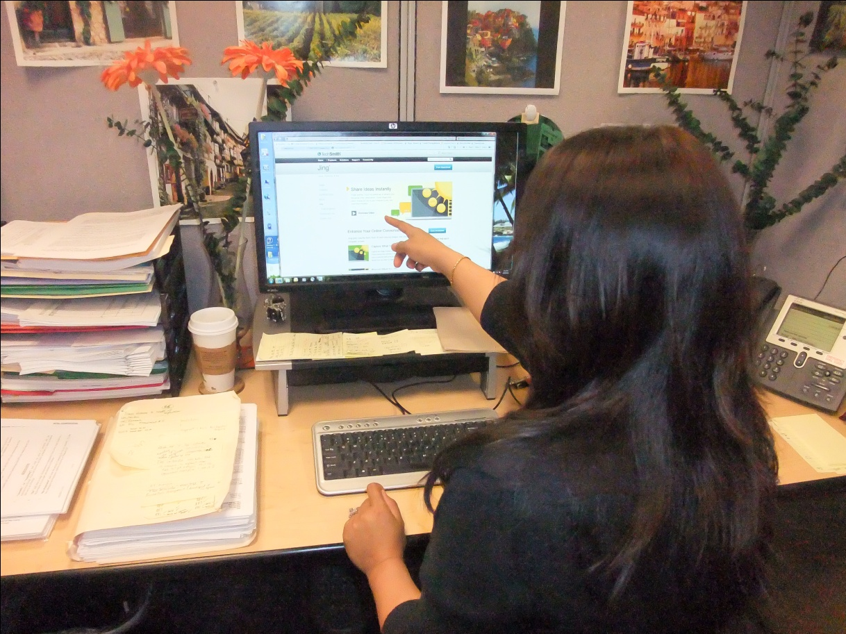
Once I receive all the content from the analysts, I will save the material on a central shared drive, which all analysts can access at any time.

Reflection
Initially, the thought was that this software could save valuable time and resources by eliminating the need for the finance analysts to spend hours training others to cover for vacation, sabbatical, and maternity/paternity leaves. The feedback I received throughout the lessons was that this software could also be helpful in communicating processes with a wide range of stakeholders beyond our close-knit finance team. As the analysts are completing their assignments, I have also received additional feedback that this project is helping them to realize more opportunities to streamline by identifying unnecessary and redundant steps in their processes.
Finally, since the minutes from our lessons and all the material created as a result will be saved on a central shared drive, I am hoping this will encourage us all to learn from each other’s content. This is bound to lead to even further improvements and result in even more efficiency and savings for the finance team and the company overall.

